**REMOTE COMMUNITY REPAIR CAFE**

**EDEN ZONE - RHINO CAMP REFUGEE SETTLEMENT**

**ARUA - UGANDA**

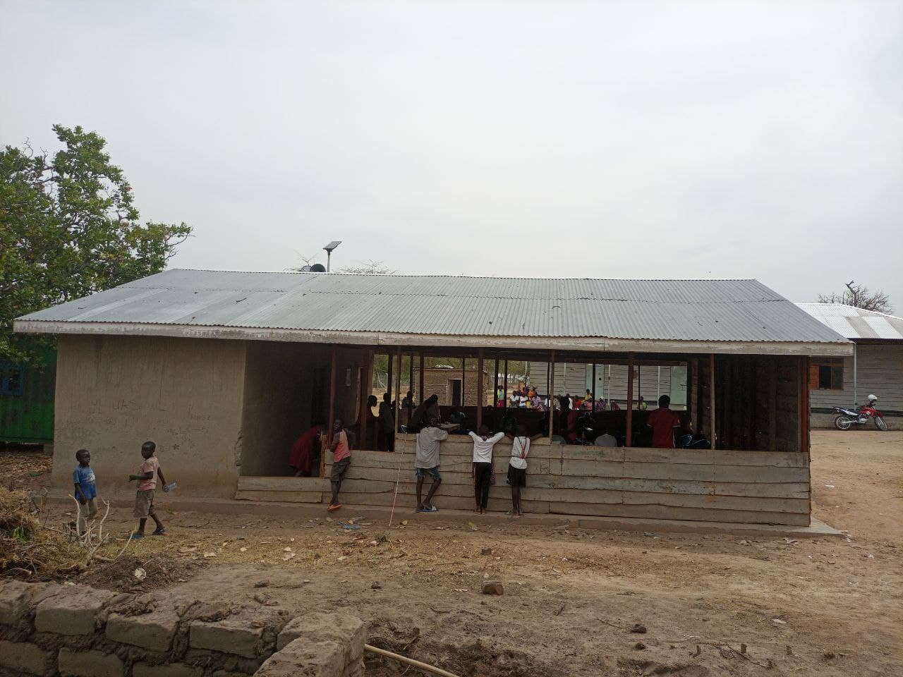

# 

Figure 4

Table of Contents

**1.0** **INTRODUCTION** 2

**2.0** **ACTIVITY STEPS:** 2

2.1 **Team setup / Responsibilities Allocation.** 2

**2.2** **Space Setup** 3

**2.3** **Registration Team** 3

**2.4** **Repair Team** 4

**2.5** **Education Process.** 6

**2.6** **Social media** 6

**2.7** **Documentation Team** 6

**2.8 Feedback** 7

**3.0** **Summary of the day** 7

**4.0** **The electronic and mechanical appliances received** 7

1. **Tools and Materials used during the Repair Cafe** 8

## INTRODUCTION

The Remote repair Cafe for ASKnet 2020 project (Online training) was a Hands-on Community repair in collaboration with other Open Tool Collaboration teams in Berlin South Sudan (Juba and Bor) among others, it was for Electronics and Mechanical appliances using the Mobile training Kit @ASKotec to help both the host and refugee community to get their stuffs fixed for free- stuff that might otherwise lie unloved at the back a cupboard or end up in landfill when it could be brought back to life.

Repair Cafés are entirely volunteer activities, carried out by people who offer their time to help others.

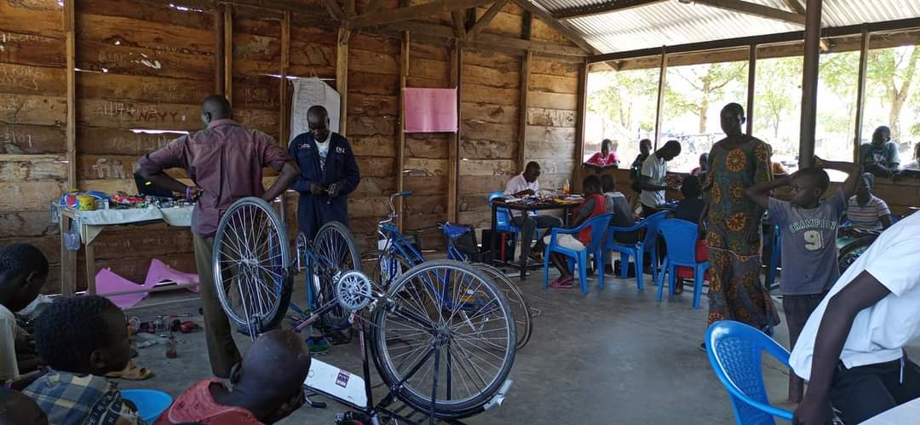

Figure 2

## ACTIVITY STEPS:

## 2.1 Team setup / Responsibilities Allocation.

The first activity done was setting up the team according to what they can do better, so we came up with five teams.

* 1. Reception /Information, Tools and Materials Security team members were Mawa Robert and Khemis Ezibon Morris.
     1. Registration team comprised of Khemis Ezibon Morris and Mawa Robert
     2. Repair Team, the team members were Geofrey Kenyi August, Sebit Emmanuel and Luate John.
     3. Documentation Team - Dawa Edina Hillary
     4. Social media and Feedback Team - Maliamungu Richard
     5. Team leader – Mathew Lubari (online)

## Space Setup

The second thing was to setup the space according to the number of the teams.

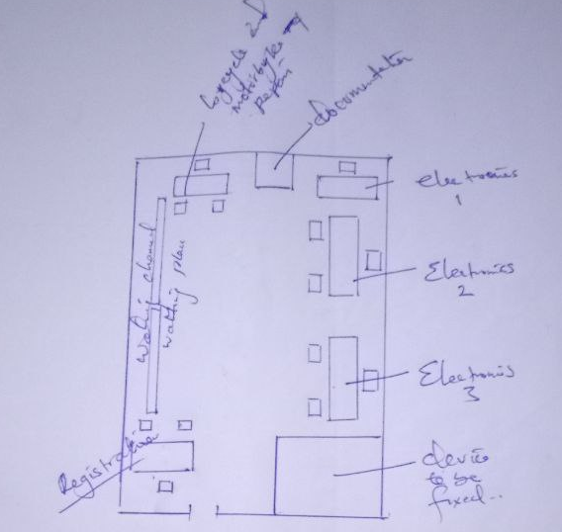

**Figure 2:** space setup

## Registration Team

* Next to the entry
* They registered all the devices to be repaired and asked few questions like the owner’s name, contact, location and the problem to be solved.
* Tagged all the devices using a masking tape and writing the owner's name on it for easy identification.

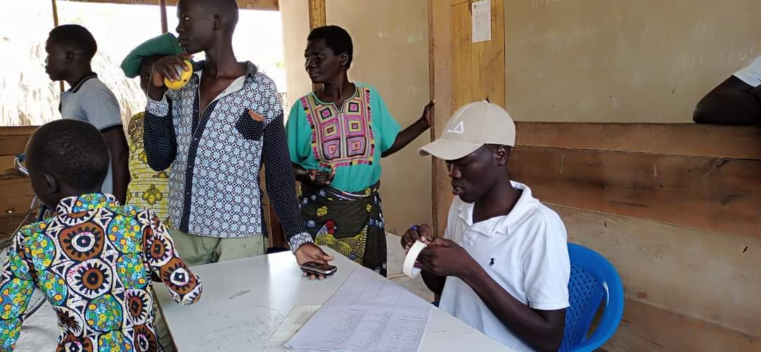

Figure 4

## Repair Team

* The team’s table was placed at the centre of the repair Hall
* They started the event by sorting the devices that can be repaired and those that cannot be repaired maybe due to spare parts absence or were badly damaged were returned to the owner immediately to avoiding wasting of their time.
* Then followed by the repair process which was done in the presence of the device owner

**Figure 5, 6 & 7: Electronic Repair Team**

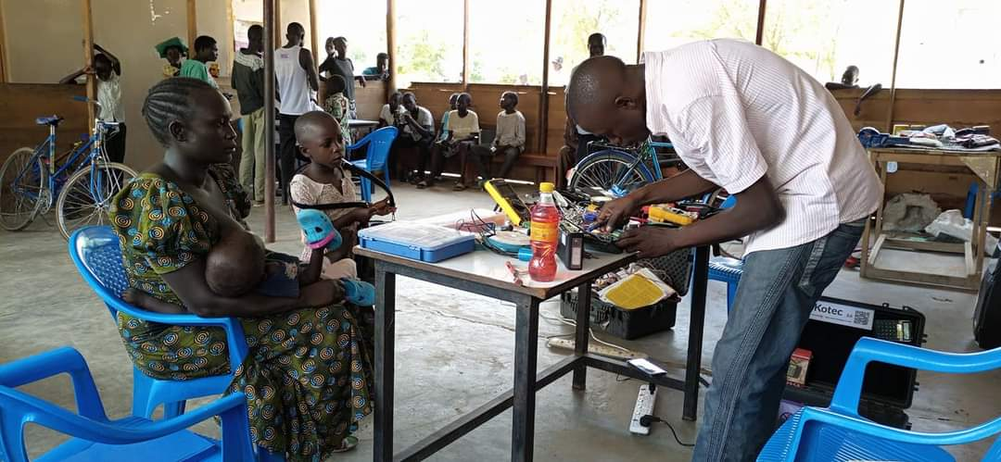

Figure 5

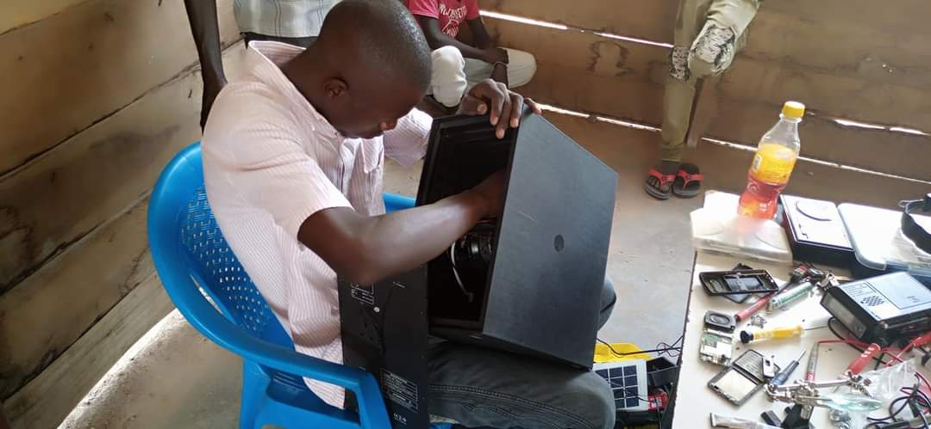

Figure 6

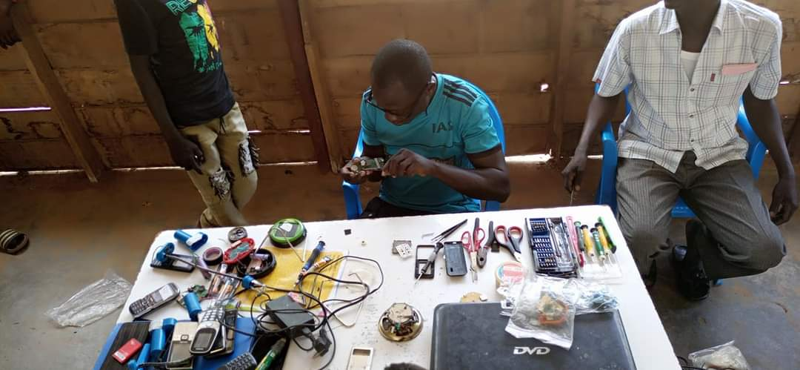

Figure 7

Figure 7

**Figure 8 & 9: Motorcycle repair Team**

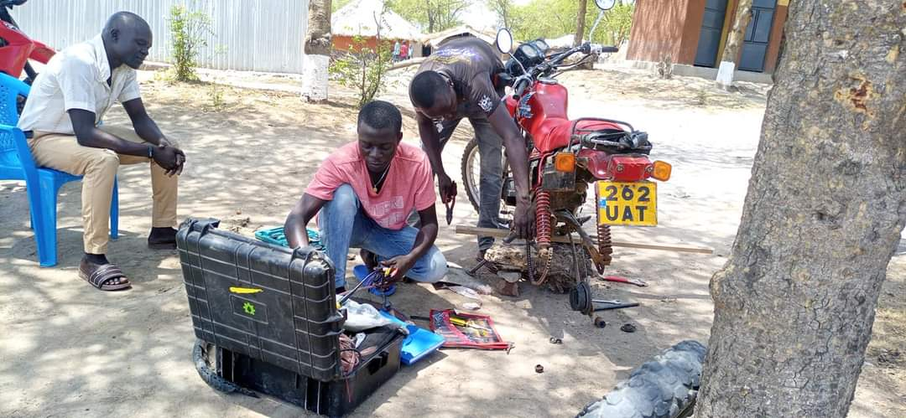

Figure 8

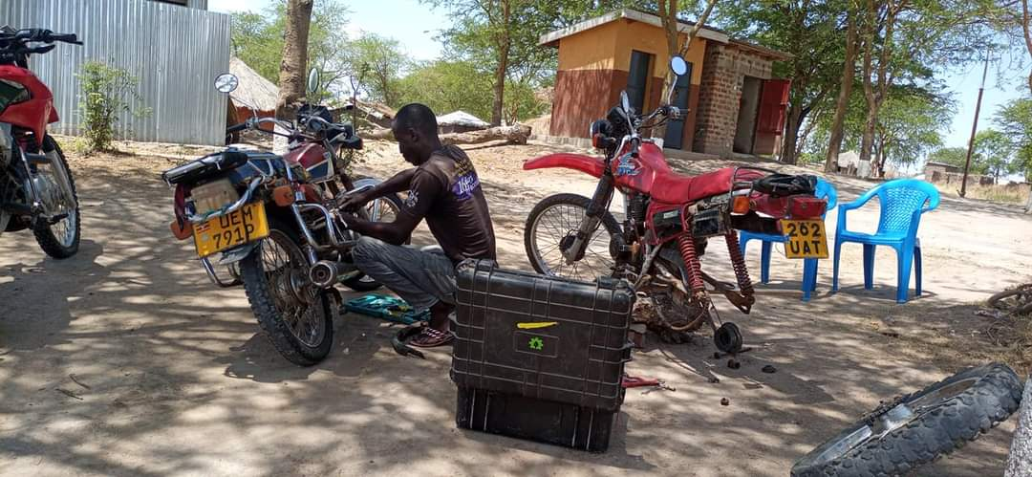

Figure 9

Figure 10: Bicycle Repair Team

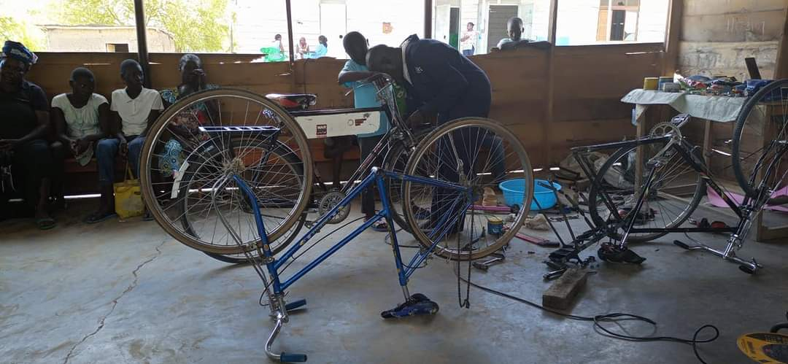

Figure 10

Figure 9

## Education Process.

Done by the repair team immediately after repairing a device, the owner was taught basic skills on how to handle and repair their devices which normally takes 1 - 2 minutes

## Social media

This team was responsible for the online collaboration aspect by ensuring that tools like Computer/Smartphone, Internet were available to connect the event live and made posts to different platforms.

## Documentation Team

It was placed in a location that they were able to observe all the activities in the Repair Hall and document every step followed.

**Figure 11: Documenting the event**

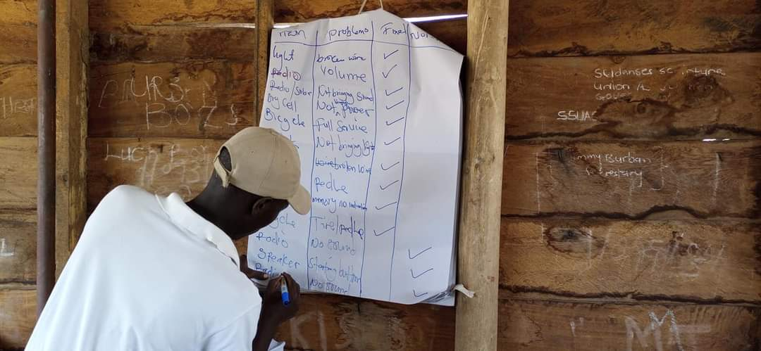

## 2.8 Feedback

After the Repair Process, the device owners were asked to give feedback about the repair whether the problems were fixed or not.

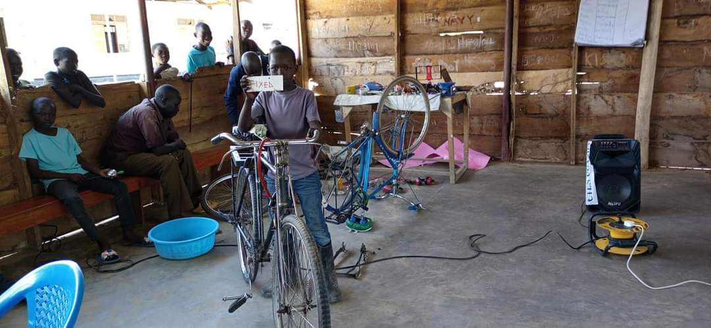

Successfully fixed bicycle

## Summary of the day

* 200 + Community members shown up for the event.
* 130 members were attended to due to fear of COVID 19 (community leaders’ restrictions).
* 32 mechanical appliances were fixed (29 bicycles and 3 motorcycles)
* More than 100 Electronic devices were fixed.
* Eight (8) expertises made sure that the visitors well served which led to the success of the event.

## The electronic and mechanical appliances received were:

* + 1. Radios
    2. Phones
    3. Speakers
    4. Lamp (Solar Lights)
    5. Inverters
    6. Power banks
    7. Bicycles
    8. Motorcycles

## Tools and Materials used during the Repair Cafe;

**Figure 12 & 13: electronics repair tools**

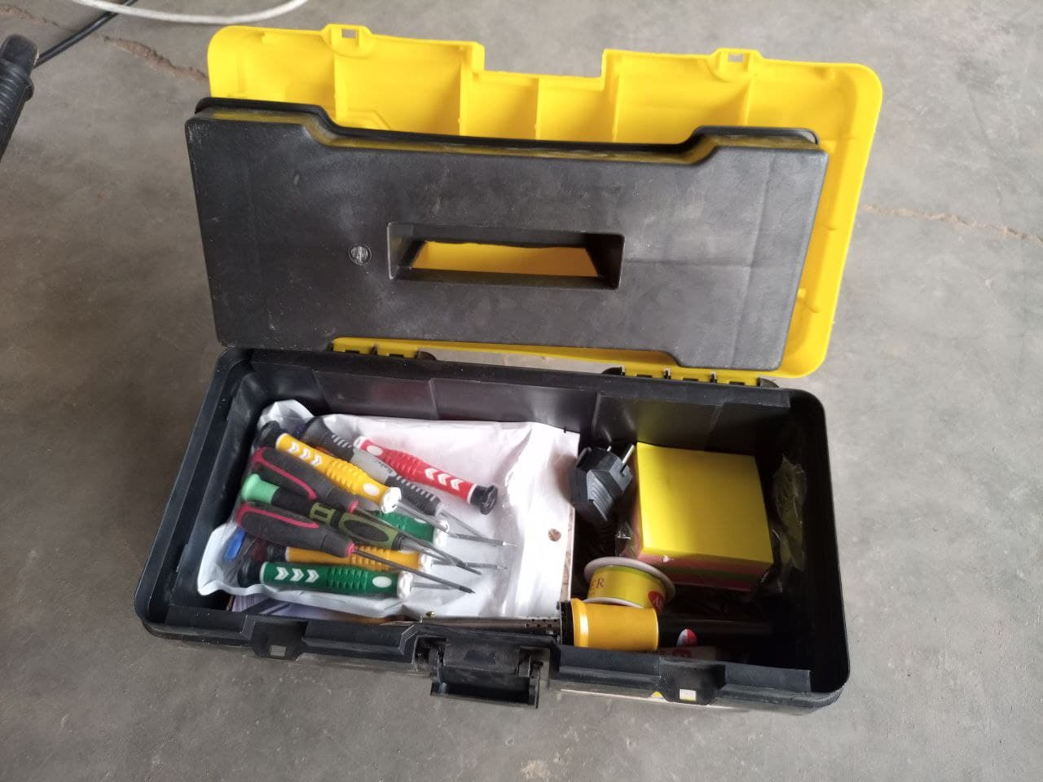

* + - Soldering iron
    - Screw driver
    - Digital multimeter
    - Magnifying glass
    - Computer
    - Camera and Smartphones
    - Flip Chart
    - Maker Pens
    - Masking tape
    - Notebooks
    - Pens
    - 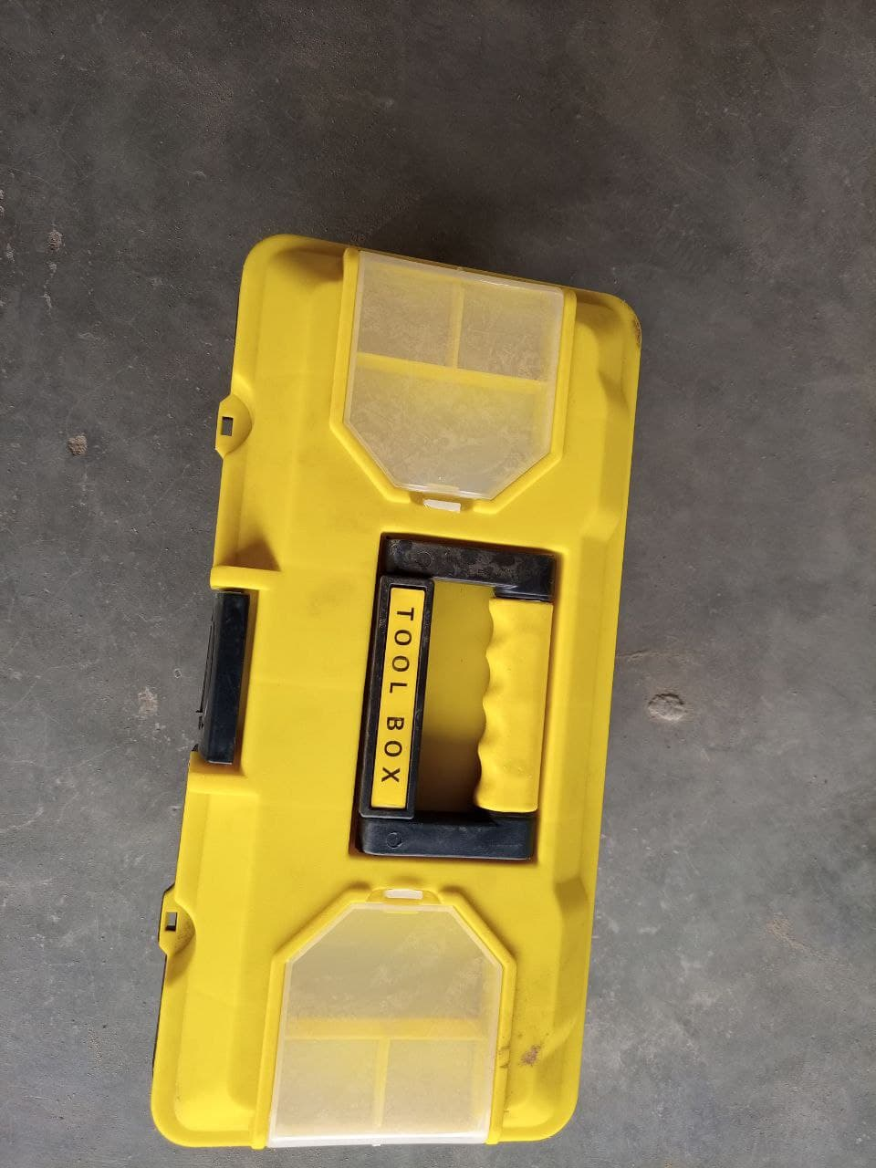Tools Kit

Materials

* + - Mouthpiece
    - Batteries
    - Soldering wires
    - Connector wires
    - Soldering oil
    - Resistors
    - Diode.



**Figure 14: Repairing Mechanical appliances using the ASKotec kit**